ABSTRACT: This is a sample file demonstrating the style for SHMII-10 papers. The length of the paper is limited to eight pages. The paper should be written in English. It must consist of an abstract, a list of key words, an introduction, one or more main sections, a conclusion, and a list of references. Please carefully follow the guidelines given in this document. Papers not complying with the guidelines will not be included in the proceedings of SHMII-10.

Guidelines for SHMII-10 papers

Author_11, Author_22, Author_31

1Department of Civil Eng., Faculty of Engineering, University of Porto, R. Dr. Roberto Frias, 4200-465 Porto, Portugal

2Department of Mechanical Eng., Faculty of Engineering, University of Porto, R. Dr. Roberto Frias, 4200-465 Porto, Portugal

email: author1@fe.up.pt, author2@fe.up.pt, author3@fe.up.pt

KEY WORDS: SHMII-10; Full paper; Sample file.

# General guidelines

Your SHMII-10 paper should be formatted in the same way as this sample file. Please follow the same double column layout and do not change margins, font styles or sizes, or heading numbering schemes.

The paper must be written in English [1]. The length of the paper (including references) is limited to **eight pages**. The paper must be submitted as a PDF document, and optionally also as a Word document. The file size should not exceed 10 MB for PDF and 30 MB for Word files. Headers and footers will be added to the paper by the editors, so please make sure the PDF file is not protected in any way.

The paper must be uploaded on the SHMII-10 web site [www.fe.up.pt/shmii10](http://www.fe.up.pt/shmii10). The deadline for submission is 10 January 2021. Papers submitted later than this deadline may not be included in the proceedings of SHMII-10. The presenting author must register and pay the registration fee before the deadline for the paper to be included in the final program of the conference.

# Structure of the paper

## Title

The title of the paper must be identical to the title of the abstract that has been submitted.

## Authors

A comma-delimited list of authors must be given, with full affiliations in the form Department, Company/Institution, Address, and a comma-delimited list of email addresses.

## Abstract

The abstract must give a summary of the paper. It must include the following elements:

* the motivation for the proposed research
* an outline of the methodology followed
* an overview of the results
* the conclusions.

The length of the abstract is limited to 15 lines. The paper abstract will be used for the book of abstracts of SHMII-10. The abstract should therefore be self-contained and it must not refer to the other parts of the paper (such as the list of references).

## Key words

Include a concise list of key words (not more than ten), for example: Bridge dynamics; Human induced vibrations; Inverse problems. Key words should be capitalized and separated by semicolons and the list should be terminated by a period.

## Main sections

The main part of the paper should start with an introduction and end with a conclusion. Section and subsection headings should be formatted and numbered as in this example file. The sections *Acknowledgments* and *References* should not be numbered.

## References

A numbered list of references should be provided. Make sure that all references are complete: for journal papers, provide initials, name, journal, volume, number, page numbers, and year; for books, provide initials, name, title, edition, publisher, city, country, and year.

# Equations, figures, and tables

Equations should be centered and the numbering should be right-justified. Here is an example of an equation:

()

Use standard symbols and nomenclature. Quantities should be expressed in SI units [2].

Figures and tables should be centered, numbered, and provided with a caption. Figure captions must be placed below the figure, while table captions must be placed above the table. All figures and tables must be explicitly referred to in the text of the paper. Examples are shown in figures Figure 1 and Figure 2 and in table Table 1. If you include photographs or other bitmaps, please make sure that the quality is sufficiently high for printing (at least 150 dpi).

figure1

Figure 1. First sample figure.

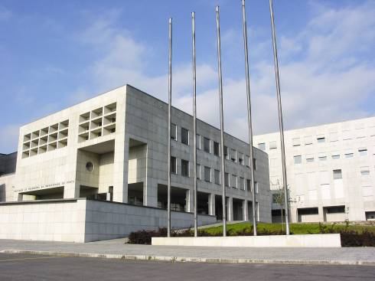

Figure 2. Second sample figure.

Table 1. Sample table.

|  |  |  |  |
| --- | --- | --- | --- |
| Mesh size | 60 × 20 | 150 × 50 | 300 × 100 |
| Method 1 | 0.65 | 75.19 | - |
| Method 2 | 0.15 | 0.72 | 1.85 |
| Method 3 | 0.13 | 0.69 | 1.98 |
| Method 4 | 0.13 | 0.78 | 2.18 |

# ACKNOWLEDGMENTS

This optional section contains acknowledgments.

# References

1. J. Simpson and E. Weiner, Eds., *The Oxford English dictionary*, Clarendon Press, Oxford, UK, second edition, 1989.
2. Bureau International des Poids et Mesures, *The international system of units (SI)*, BIPM, Paris, France, eighth edition, 2006.