TPDL2018
- Help: EasyChair: Contents
- FAQ: EasyChair: Frequently Asked Questions
Note: (some of) The URLs generated by EasyChair are unique to one user, so you can not share them with another user.

1. General
Not easychair things.

1.1 Conference Web pages
- (@TiagoDevesas using Wordpress)
- Conference site: http://www.tpdl.eu/tpdl2018/

1.2 Create conference Gantt
- : Conferences schedule HELP
- : PowerPoint chart HELP
- TPDL_DCMI_gantt: Drive spreadsheet

2. EasyChair
There is a conference management system called EasyChair which many of the academic conferences use to manage the submission to the conference, the reviewing of the submissions, and the selection of the papers to be included. It is tried and true, but it has one of the worst user interfaces you are likely to ever experience. This post is the result of my struggle to get it set up for an event. Agile Software Craftsmanship, Not-So-EasyChair Hints, jan 2014
Since our installation of EasyChair only supports uploading one paper with .pdf extension, please add the .pdf extension to the .zip file before uploading it. JCL, MCR, Camera-ready submission instructions, jun 2018 Better use the "Proceedings"!
- Easychair & conference workflow; Admin > Workflow

2.1 Apply for a new conference
- EasyChair > Apply for a new conference installation
- free license includes Springer LNCS proceedings, does not include helpdesk: licenses

2.2 Initiate the conference
- Login page: https://easychair.org/conferences/?conf=tpdl2018

2.3 Initial settings
- acronym: TPDL2018
- Admin > Configure
- tpdl2018@easychair.org → jlopes@fe.up.pt, mcr@fe.up.pt
- tpdl2018@googlegroups.com
- ✘
- ✘

2.4 Create a demo version
- Admin > Demo version
- https://easychair.org/conferences/demo.cgi?a=16560272

2.5 Keynote speakers
- to the conference Web pages

2.6 Program committee members
- PC -> Add New PC Members HELP
- PC -> Send Email to PC Members
- PC status: PC -> Invitations to PC
- to the conference Web pages

2.7 Call for papers
- CFP
- (CFP) Edit
- (CFP) Publish
- https://easychair.org/cfp/TPDL2018

2.8 Submissions
- Conference Settings Overview: Admin > Configure > Overview settings
- ✘
- Admin > Configure > Submission form
- Admin > Configure > Submission form HELP
- to your conference Web pages
- of your PC to submissions Admin > Configure > Access to submissions
- of senior PC members Admin > Configure > Settings for senior PC members
- (08/02/2018 15/02/2018) Admin > Configure > Paper submission
- Submission deletion: Submissions > Delete submission(s)
- Email to authors: Submissions > Email to Authors
- TPDL2018 List of Submissions: Submissions

2.9 Reviewing
- tpdl2018@easychair.org → jlopes@fe.up.pt, mcr@fe.up.pt, emendez@bib.uc3m.es, fabio.crestani@usi.ch
- Admin > Configure > Reviewing
- (08/04/2018 16/04/2018) Admin > Configure > Paper submission
- without topics (ASAP) PC > Topics > Email PC members with no topics
- when all submissions arrived (16/04/2018)Admin > Configure > Paper bidding and assignment (enabled = "on")
- View paper bidding: View bids
- PC > View PC > Find conflicts OR Assignment > Automatic Assignment> Potential Conflicts
- PC > View PC
- not yet done Assignment > Automatic Assignment > "send reminder..."
- Admin > Configure > Paper bidding and assignment (enabled = "off")
- Enter bids for reviewers without biddings Assignment > Automatic Assignment > "enter bids for these..." ✘
- for PC Members Assignment > Individual Assignment Bounds for PC Members
- to your program committee for reviewing Assignment > Automatic Assignment HELP
- to PC members Assignment > Interactive Assignment HELP
- Admin > Configure > Reviewing
- Admin > Configure > Reviewing
- (09/04/2018 28/04/2018)Admin > Configure > Reviewing (enter reviews = "yes")
- Assignment > Send to PC
- Assignment > Send to PC
- Current Status of Reviewing: Status
- Reviews > Missing reviews
- Admin > Configure > Reviewing (enter reviews = "no")
- Email > Email to PC

2.10 Paper selection
- Conference Statistics: Admin > Statistics
- Admin > Configure > Reviewing
- Status > Current Status of Reviewing > Change decisions
- Open the review response (rebuttal) phase Admin > Configure > Review response period (start|stop) ✘
- about submissions
- Admin > Configure > Reviewing (enter reviews = "no")
- and/or reviews to the authors (02/06/2018) Reviews > Send to authors
- Camera-ready submission done in TPDL2018:
  - Admin > Configure > Paper submission (The submission page is = open for updates of previously submitted papers)
  - Admin > Configure > Submission form File upload fields in the submission form
- Camera-ready using EasyChair: View demo version? And read "Next TPDL" below!
  - Add new proceedings to put together all submitted files in the format required TPDL2018 > Create proceedings
  - Add papers and send email to authors Proceedings > Add Papers (email authors with LNCS instructions)
- in the TPDL site
- List of accepted papers: TPDL2018 Accepted Papers

2.11 Conference
- Statistics by Topic Admin > Statistics > Statistics by Topic
- Create conference program Admin > Create program HELP
- Drive spreadsheet
- in the TPDL site
- in the TPDL site

2.12 Proceedings
- LNCS 11057
- Admin > Configure > Paper submission
- of accepted papers
- in EasyChair.
- (see SV checklist bellow)
- How to prepare the proceedings: http://ens.ewi.tudelft.nl/~galuzzi/Proceedings_Preparation.html

3. SV Checklist (Publication)
Here is a checklist of everything we require from the volume editor [TPDL2018.zip]:
- : source and PDF file. [tpdl2018.pdf] [Proceedings.zip]
- (incl. topical headings): any type of electronic version. [tpdl2018.pdf] [Proceedings.zip]
- : sources (incl. bib files and images) and PDF files of each contribution grouped in a directory, labeled using the volume number and the starting page of the paper. [CameraReady.zip]
- : one for each paper, signed by the corresponding author. [CameraReady.zip]
- that are not straight forward (Given Name; Family Name). [?]
- : suggestion for the main title and for the subtitle, where applicable. [tpdl2018.pdf] [Proceedings.zip]
- : for inclusion on the cover (where applicable). [tpdl-logo.tif]
- , giving details on the names and affiliations of the volume editors, the title of the book, and the information required for our LOD portal. [Editors.gdoc]
- : one per paper. The list should include the starting page number of the paper, so that it is clear which email address belongs to which paper. [Authors.gdoc]
- (online access, USBs, print, etc.) of proceedings copies required for distribution at the event. [1stReadme.gdoc]
- you would particularly like to draw our attention to (specifics of delivery, billing procedure, etc.).
Cover Sponsors Preface Organization Toc & Author index

4. Configuration status
Status on 23/05/2018 15:28

4.1 conference
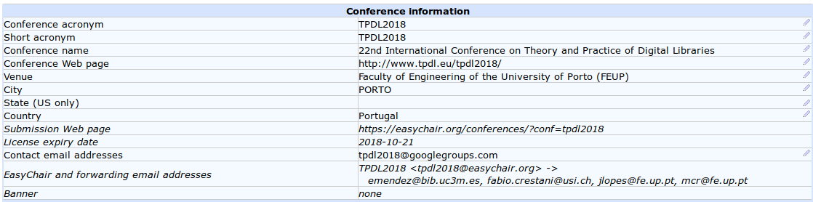

4.2 submission
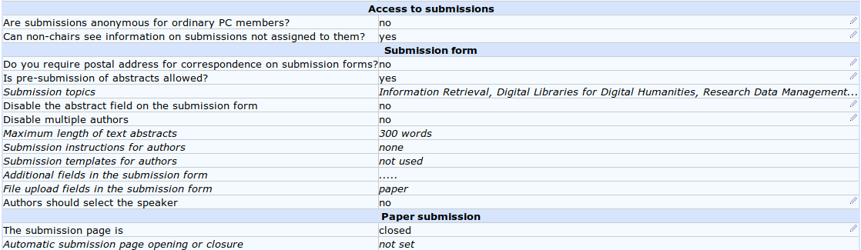

4.3 assignment
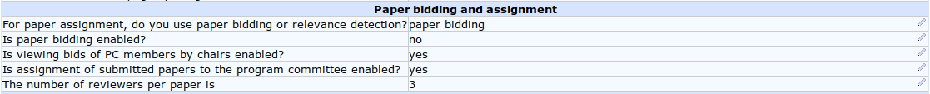

4.4 reviewing
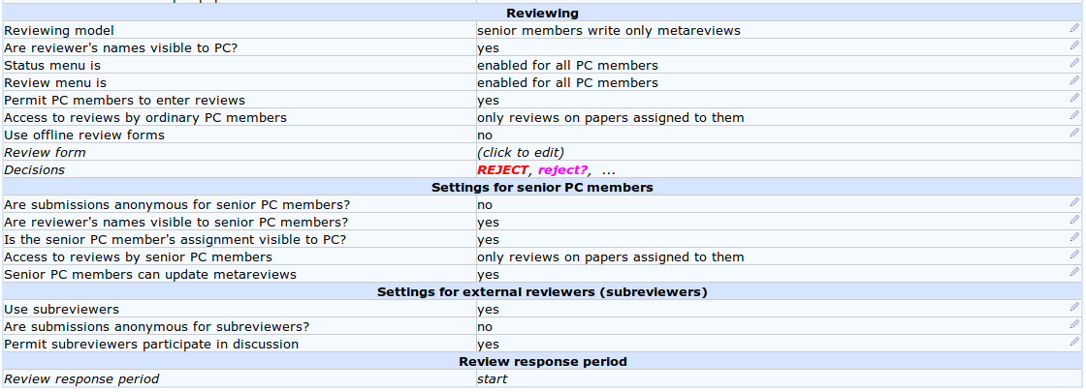

4.5 Next TPDL
- after paper acceptance initiate the "Procedings Environment"
- go with it and generate the LNCS proceedings file to sent to Speinger

Proceedings Workflow
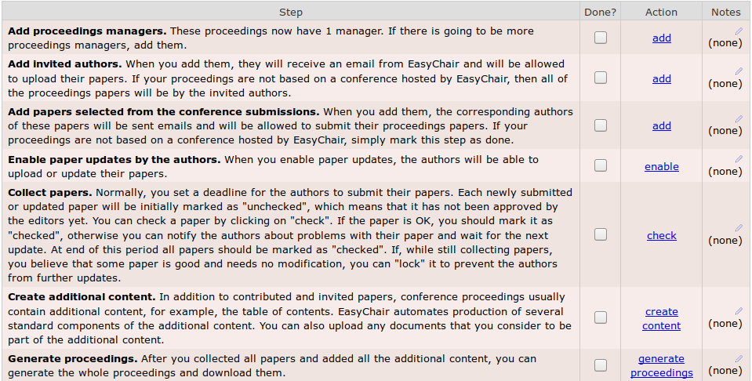

Proceedings Settings
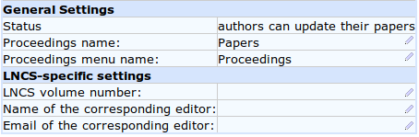

TPDL2018 Proceedings Content
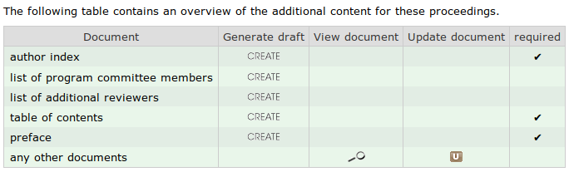

Order of Papers
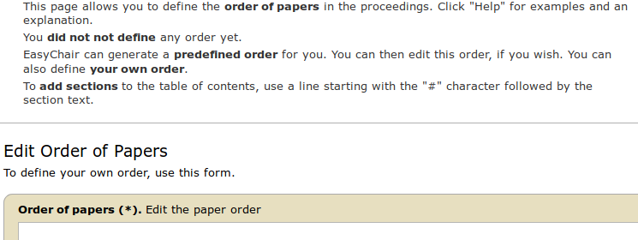

Invited Authors
- add invited authors

List of Emails
- list emails & send emails

generate LNCS package
- do some editing first

End
— Correia Lopes, 26/10/2017 11:45

