Using an Intranet for Effective Communication

Lígia M. Ribeiro and Gabriel David

Faculdade de Engenharia da Universidade do Porto

Abstract
The paper describes how an information system based on a database, and accessed by standard Web browsers, became an effective support for communication due to an integrated approach to modelling information coupled with some specific modules offering communication services.

0 Introduction

The Intranet of the Engineering Faculty of the University of Porto, called SiFEUP, is under development since 1996 (see [1]). One of the goals stated in the study [2] that launched the project was "to increase internal communication effectiveness ⎯ one-to-many (diffusion), many-to-one (recovery), one-to-one (transfer)".
This was one among several other goals, at the time deemed more important, which inherited from the view of the system as a record of information on the school's activity and as a provider of easy access to it. According to this view, the highest priority has been assigned to the modules organising the information on the degrees offered, student enrolments, academic results, department organisation, personnel, research projects and groups, and scientific publications. This information is recognised as useful both to the students and teachers inside the Faculty and as a way of promoting the image of the Faculty among companies, prospective students, and the scientific community.
However, the actual use of the system stresses the communication facilities built around it. From the viewpoint of the frequent user, already acquainted with most of the information in the system, its most valuable facet turns out to be the enhanced communication channels it offers. These include, among others, a flexible mailing list facility and a generalised set of Web pages.

1 Dynamic Mail

Among the communication components, the most popular module is Dynamic Mail. It consists on a Web based facility to send e-mail to a selected group of receivers, defined on the fly by its characteristics, instead of using a predefined distribution list.
SiFEUP contains information on virtually all the potential internal message receivers: 400 teachers and 250 staff organised in 11 departments and central services, and 5000 students spread by 8 undergraduate and about 12 graduate programs. This information records several characteristics of each person, like the name, category, department and room for the personnel, or the degree, year, and photograph for the students, and is kept up-to-date by the Personnel Service and by the Academic Service, respectively. Besides, there is an optional phone number and e-mail address, which may be local (everyone has an e-mail account in the Faculty computer system) or located in another more convenient place.
The system can thus be used as an e-mail directory because, using a form like the one shown in figure 1, it is very easy to find someone even if only partial information is known. The obvious advantage is to replace the multiple private directories, always outdated, by a centralised and maintained service, thus improving one-to-one communication.

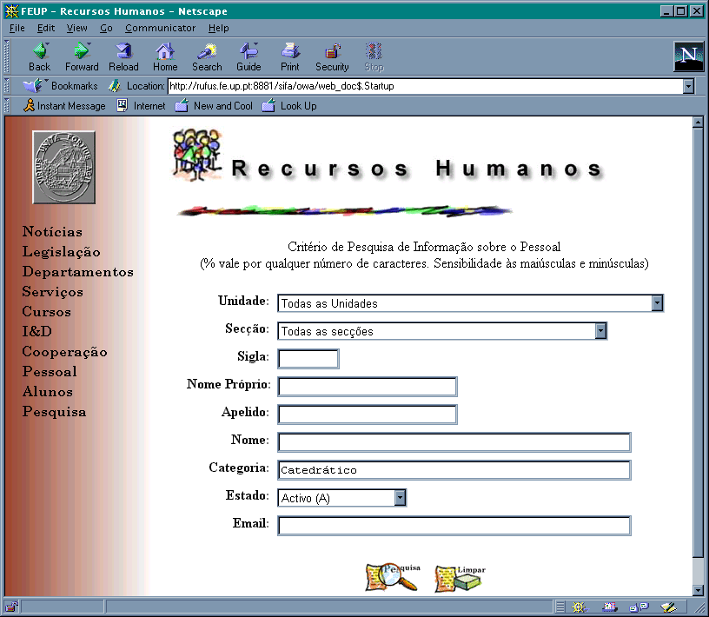
But the full power of the Dynamic Mail module comes from its ability to replicate a message to everyone in an arbitrarily selected group. In fact, if the search criteria specified in the form is general enough, several people may qualify. For instance, if only the category is specified, it is possible to select all the full professors and send them a message reminding of a meeting. The message will reach all of them including the recently appointed, because as soon as their new category is recorded they start to belong implicitly to the list without any other action. This stems from the integrated approach taken by SiFEUP, different from the traditional distribution list services.
Figure 1. Search form for teachers.
As another example, it is possible to instantly send a message to all the 2nd year students of a certain degree, or to all the students named Silva. The form used to do this is shown in figure 2. The right list box contains all the recipients found by the previous query. One can refine it by marking only a subset as the actual selection. The contents of a message is basically text. Currently, the concept of attached documents is not supported.
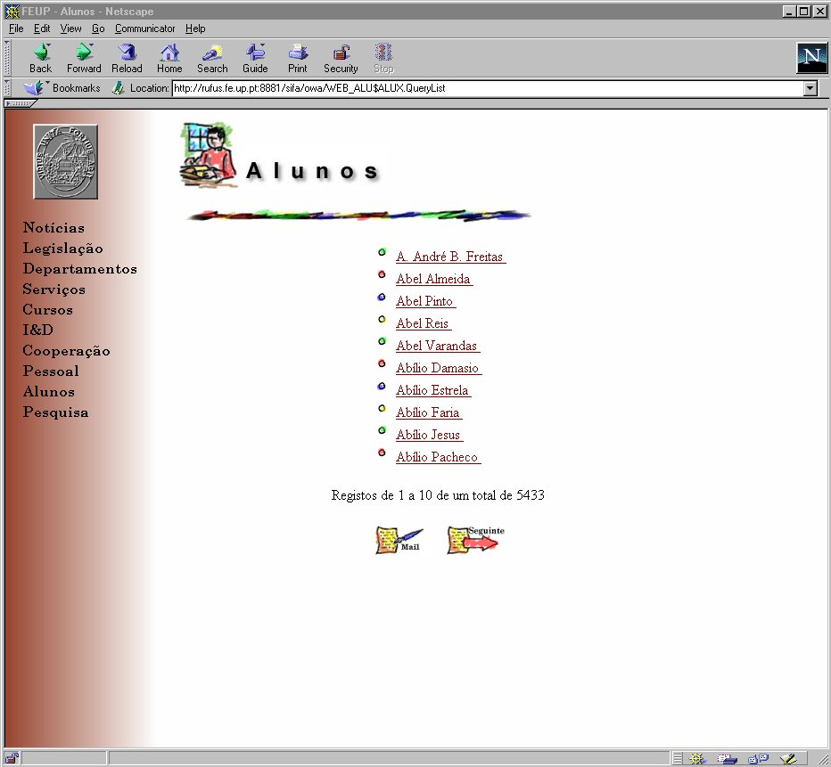
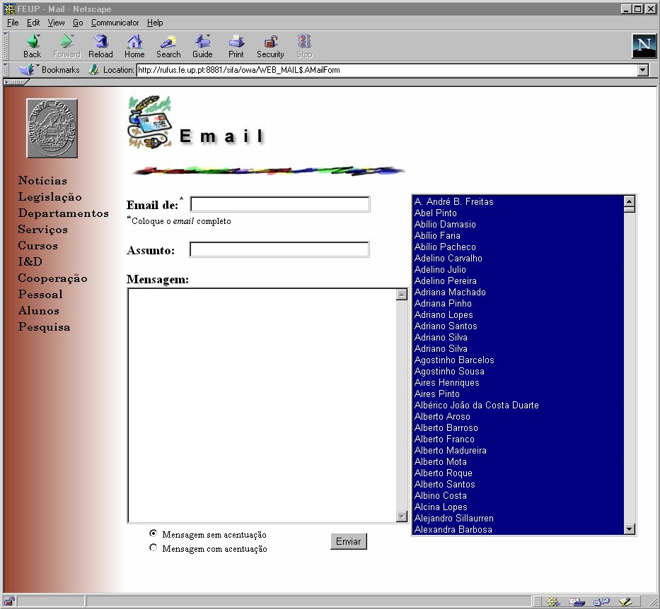
Generally, the lists of persons generated in different components of SiFEUP have a Mail button associated invoking Dynamic Mail on that list. A specially useful one is the list of students enrolled in a specific course. The list is generated by clicking on a button in the page describing the goals, program and teachers associated to the course, and can be used for the presence or the mark sheets, or as the target for a message concerning that course. So, every teacher, or in fact any person, can reach the students of a course a week after the end of the registration period, as a result of the integration between the Dynamic Mail module and other SiFEUP components. This is an example of one-to-many communication.
Search Result
Mail Form
Mailer.pl

CGI connects to Unix port 25
The Faculty has the policy of maintaining the data of the former students in SiFEUP and of offering disk space to host their Web pages. As long as they keep their e-mail addresses updated, they can be reached by the mechanism we have been describing, increasing the ties with their originating school.
PL-SQL
Perl
Figure 2. Sending an e-mail.

2 Consistent set of Web pages

Another mechanism that is becoming more and more used is the creation of Web pages both for personal and for course information. In many systems, only some names actually link to a page and the information displayed varies so much in contents and format that finding the required information becomes a difficult task.
In SiFEUP, it was decided that every person connected with the Faculty (students, teachers, staff) possesses at least a standard Web page with the (relevant) basic facts about him: name, category, professional phone number, institutional dependence, courses taught/attended, time-table, R&D projects, scientific publications, and possibly e-mail and photo to help identification, as well as a link to a personal page with free complementary information. Space for individual creativity is thus granted, but in a framework where even non-HTML experts have their own information displayed.
Also, every course has a standard page with the official information on its contents, bibliography, teachers, etc. Those courses for which the teacher maintains specific pages with further information (teaching notes, exercises, warnings, etc.) have a link set up in the standard page, which can be reached in a systematic way. There is no need to keep track of lots of URLs for each course. This mechanism provides an on-demand access to information, in a many-to-one manner, thus reducing the e-mail traffic across the network, which increased significantly due to the Dynamic Mail. For example, instead of distributing the marks of a coursework to each student, the teacher can just add them to the course specific Web pages, where the students can find them.

3 Dealing with abuse

Easing the communication also facilitates the abuse of the new services. The general policy which has been pursued in SiFEUP is to trust the users and act by education and persuasion whenever possible, but being prepared to become more restrictive if necessary.
The SiFEUP team monitors the system and when an abnormal situation is detected the rules of good behaviour known as Netiquette are reminded and made clear according to the concrete case. A dialog is tried with the perturbing element often raising some new and interesting legal questions and also discussing the principles of free access to information, privacy and common benefit. Most of the problems are solved this way.
In the case of the Dynamic Mail, the number of bad-taste jokes and misuses flooding everybody's mailboxes forced the implementation of a log to keep track of the system use and to trace the source of problems.
Another mechanism has been set up for a more complex situation. In order to help to identify a person in a big organisation as FEUP, connecting the name with a photograph is an invaluable aid, specially for teachers. But, when the photographs were added to the students' personal pages, some of them protested, and had the right to do so under the principle of protection of the personal image. The compromise obtained was to put under individual control whether the photo is displayed on the public personal page and to create a version of the same page with the photo only accessible to the teachers via password.

4 Conclusion

We argue that, though the net result is an actual incidence on facilities formerly seen as secondary, that is only possible because the Intranet was built over an underlying structure conceived as an integrated database. It is the database that empowers the Dynamic Mail and supports an uniform access to the personal and course web pages, always keeping the information updated and coherent, a task that would become a nightmare should the system be based just on HTML technology. So, when a secretary enrols a student in a new course, he is implicitly "added" to all the corresponding (virtual) mailing lists.
Designing the Intranet around a database requires an extra effort of systematisation and modelling of a complex organisation as a Faculty is. But it pays off in terms of consistency, reliability and flexibility of the information system, which becomes an infrastructure able to support new developments.
[1] Ribeiro, Lígia M.; David, Gabriel; Azevedo, Ana M.; Marques dos Santos, José C. Developing an Information System at the Engineering Faculty of Porto University. In Yves Epelboin, EUNIS 1997, Grenoble.
[2] David, Gabriel; Ribeiro, Lígia M. Desenvolvimento do Sistema de Informação da Faculdade de Engenharia da Universidade do Porto (SiFEUP). Internal report, FEUP, Porto, 1996.

Address
Lígia M. Ribeiro
Faculdade de Engenharia da Universidade do Porto
CICA
Rua dos Bragas
4099 PORTO CODEX
PORTUGAL

